Project Planning Phase
Project Planning Document
An employee requests installation of licensed software through the Service Catalog
Date | 3-09-2026
Team ID | SWUID2026190351
Project Name | An employee requests installation of licensed software through the Service Catalog
Maximum Marks | 5 Marks

1. Product Backlog, Sprint Schedule, and Estimation
Below is the structured product backlog and sprint schedule for our ServiceNow software request implementation, detailing epics, user stories, story points, and priorities.
Sprint | Functional Requirement (Epic) | User Story Number | User Story / Task | Story Points | Priority | Team Members
Sprint-1 | Service Portal Form (/sp) | USN-1 | As an employee, I can fill a Software Request Form capturing 4 mandatory variables (Software Name, Version, Justification, Workstation ID). | 3 | High | Dev Team
Sprint-1 | Service Portal Form (/sp) | USN-2 | As an employee, I get form-field validation errors if mandatory catalog variables are left empty. | 2 | High | Dev Team
Sprint-1 | Workflow Engine | USN-3 | As a system, auto-approve standard software requests automatically without requiring manual manager delay. | 5 | High | Dev Team
Sprint-2 | Task Assignment | USN-4 | As an IT admin, automatically generate a Catalog Task (sc_task) and route it to the 'Software' assignment group. | 3 | High | Dev Team
Sprint-2 | Automation & Logic | USN-5 | As a developer, trigger custom Business Rules on the Incident table whenever a Requested Item (RITM) state becomes 'Pending'. | 5 | High | Dev Team
Sprint-2 | Tracking & Portal UI | USN-6 | As an employee, I can track live stage updates and request progress on the Service Portal ticket page. | 2 | Medium | Dev Team

Sprint Burndown Chart:
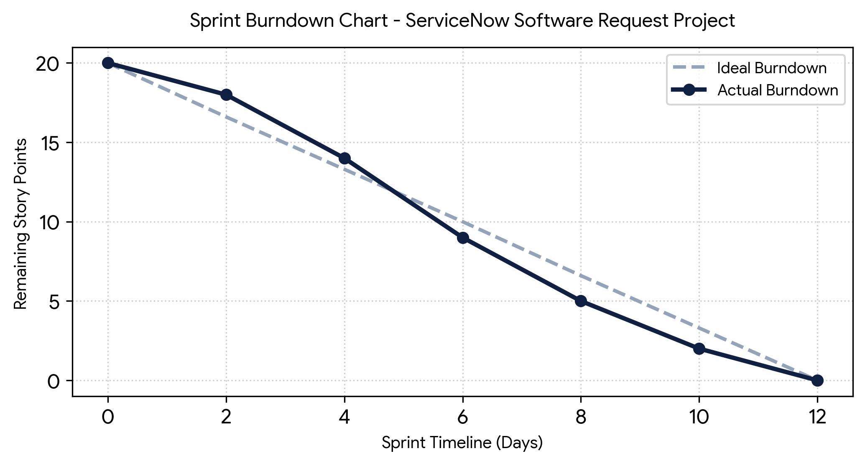
Figure 1: Ideal vs Actual Burndown Progress for ServiceNow Software Request Project

